ESTIMATION OF BUSINESS EXPENSES

SUBMITTED BY
TEAM ID:NM2023TMID30840

TEAM MEMBERS:
1.JAYAMALINI.J(E7C9AEF9148CBDCABC446779D387305C)
2.JEEVAJOTHI.S(80898D99E3F04CEBCC04848054D53EC7)
3.JEYARANI.S(8661A8BAFC0B00B953744FA82C78919A)
4.KARTHIKA.B(7EB9F41B9934035A0D34D66AA46D3AD9)



DEPARTMENT OF PHYSICS
L.R.G GOVERNMENT ARTS COLLEGE FOR WOMEN
TIRUPUR -641604

10 OCTOBER 2023
ESTIMATION OF BUSINESS EXPENSES

INTRODUCTION:

1.1 Overview:

Estimating business expenses is a crucial aspect of financial planning.
To list out all potential expenses categories relevant to your business. Common ones include rent, utilities, payroll, marketing, supplies, insurance and taxes. This project will help to review the financial records available on previous expenses. This can serve as an estimate to know the industry benchmarks and standards about the similar business spends in each category. Also this project will helps to plan the budget requirements for a business.

1.2 PURPOSE:

» To budgeting is used to help in planning.
» Identify areas for cast efficiency improvement.
» Help in identifying potential financial risks and planning.
» Investors relations provides clarity to invest to the financial visibility to business application.
» Display a summary for total expenses, categorized and any other additional notes.

PROBLEM DEFINITION & DESIGN THINKING:

2.1 Empathy map:

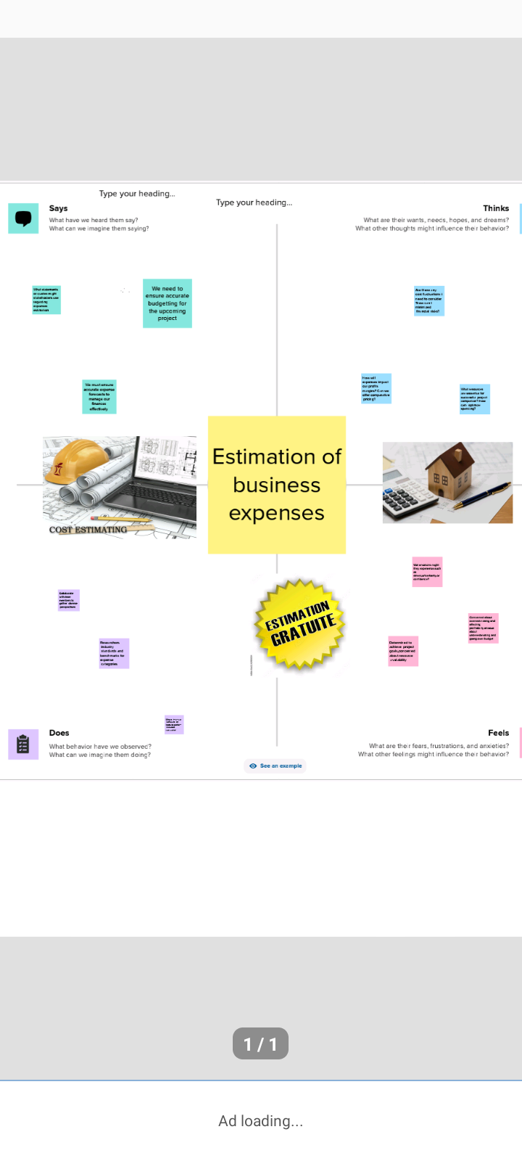

2.2 Brainstorming:
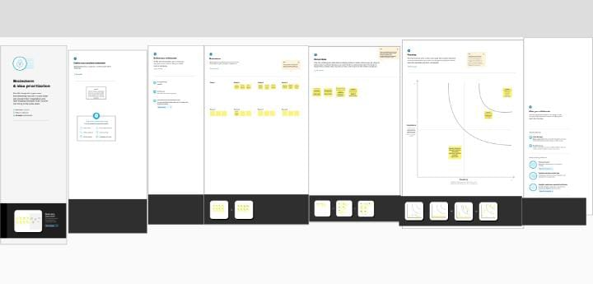

3. RESULT:
To estimate the business expenses you will need to provide more specific details about your business type and it's expenses. Typically you'd consider categories like rent, utilities, employee, salaries, marketing, supplies and more.
ANNUAI PAY ROLE

Annual pay Roll Powerful insights Annual payroll Breakdown

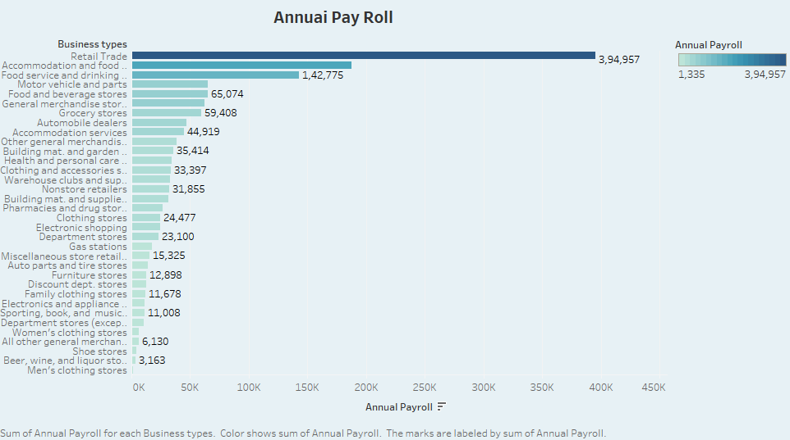

ADVERTISEMENT COST
Advertisement cost unlock success with Tableau: Affordable Advertising Solutions for All Budgets
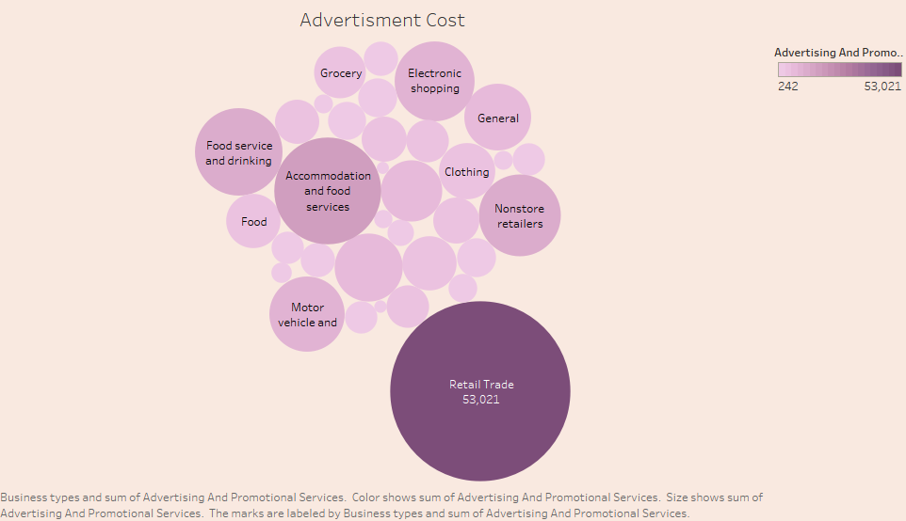

CONTRACT LABOUR VS EMPOLYEE

Contract labour Employee Tableau Contract Labor Employee Management Solutions

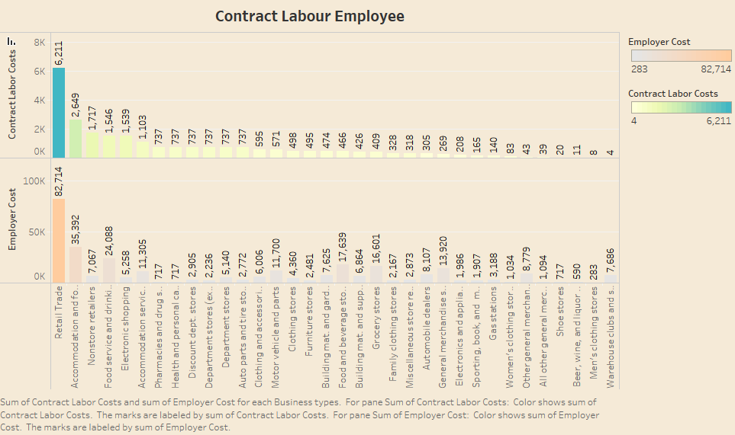

EMPLOYEE (INSURANCE VS PENSION) Employee Cost(Insurance pension) Employee Cost(Insurance pension) Empowering Employees with Robots Insurance and Pension Plans
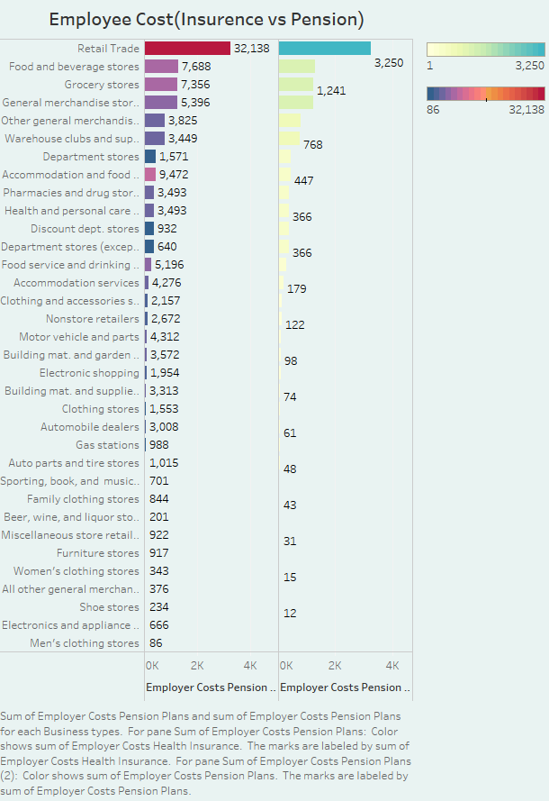

EQUIPMENT COSTS Equipment Costs Optimize Efficiency and savings Tableau Equipment cost management solutions
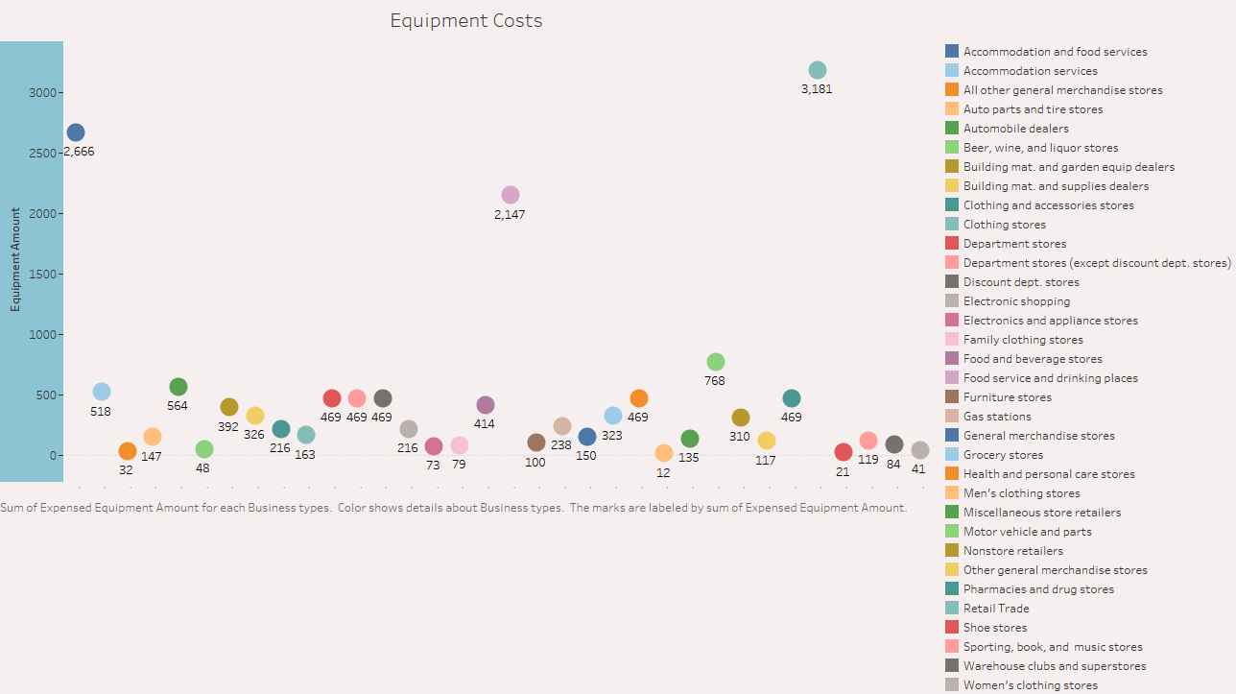

EXPENSESYOY Expenses yoy Empower yourself finacially with tableau Track and manage your expenses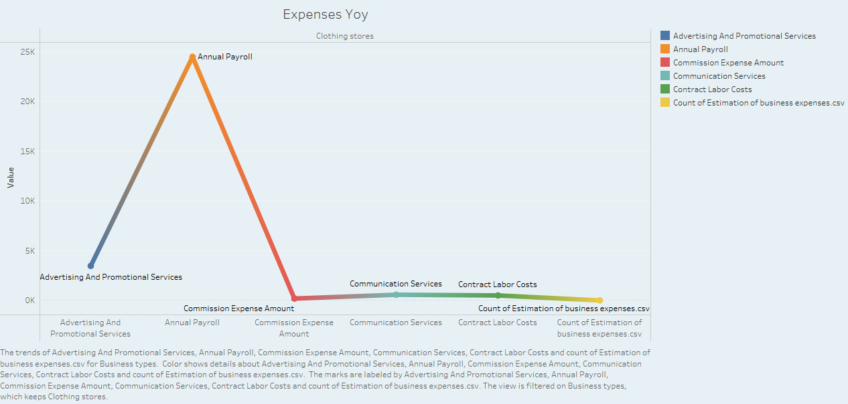

FUEL Fueling success tableaus cutting edge Solution for Fuel management

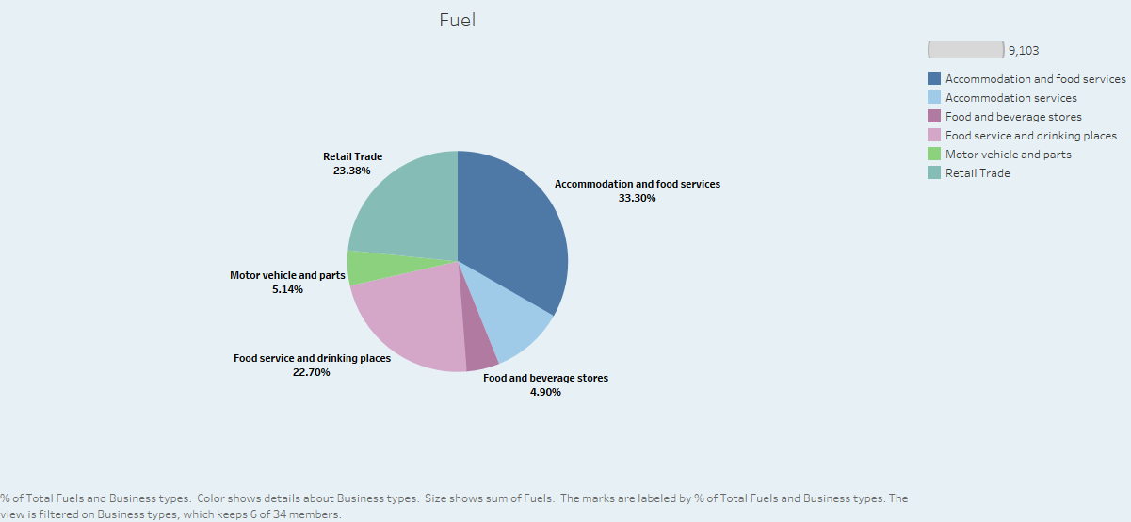

MAINTENANCE OF BULDINGS Maintenance of building Brilliance tableaus Advanced solution for maintenance management

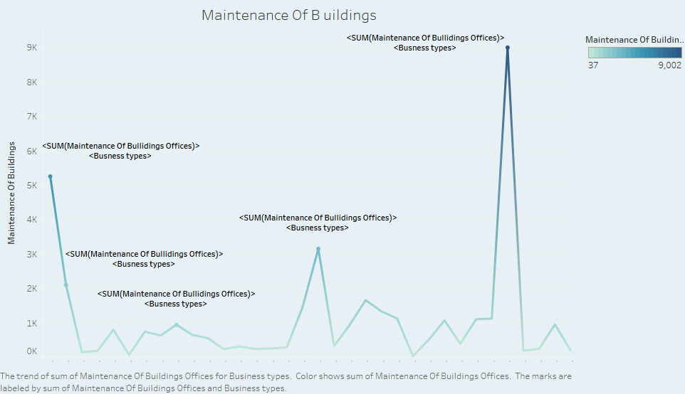

POWER EXPENDITURE Power expenditure Empowering efficiency Solutions for power Expenditure Management
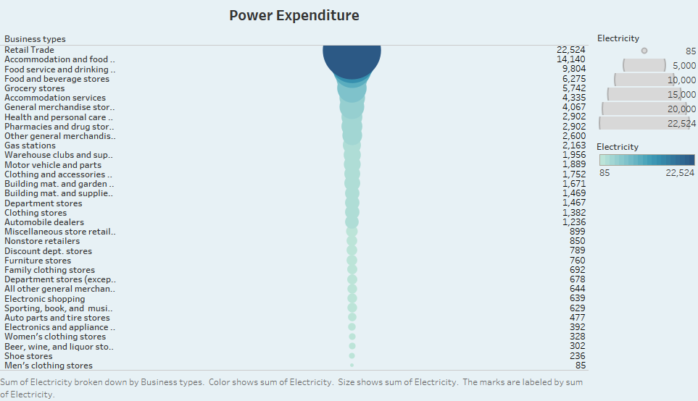

RENTAL PAYMENT MACHINERY Rental payment for machinery Streamline machinery rental payments with Tableaus efficient solutions

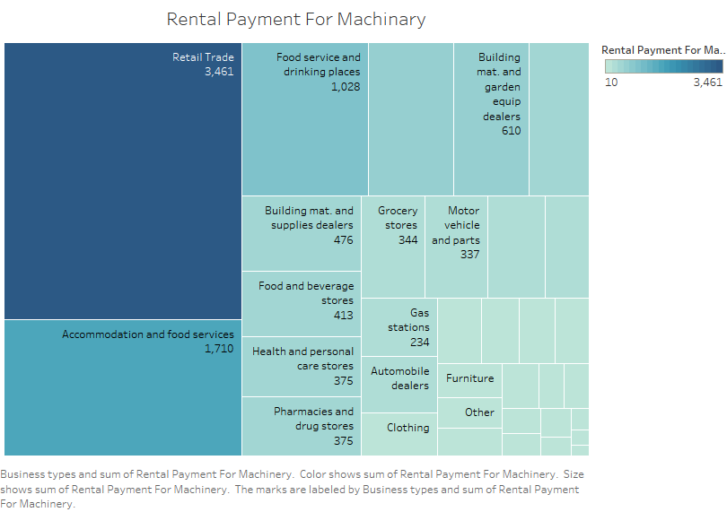

TAXES & LICENSES Taxes and licenses Navigate the tax and licensing maze with Tableaus expert solutions
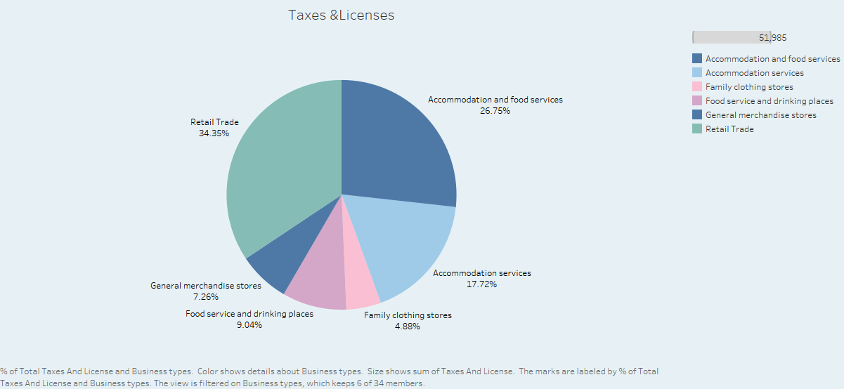

TRANSPOTATION AND WAREHOUSING Transpotation and warehousing Revolutionize your Tableaus transportation and warehousing solution

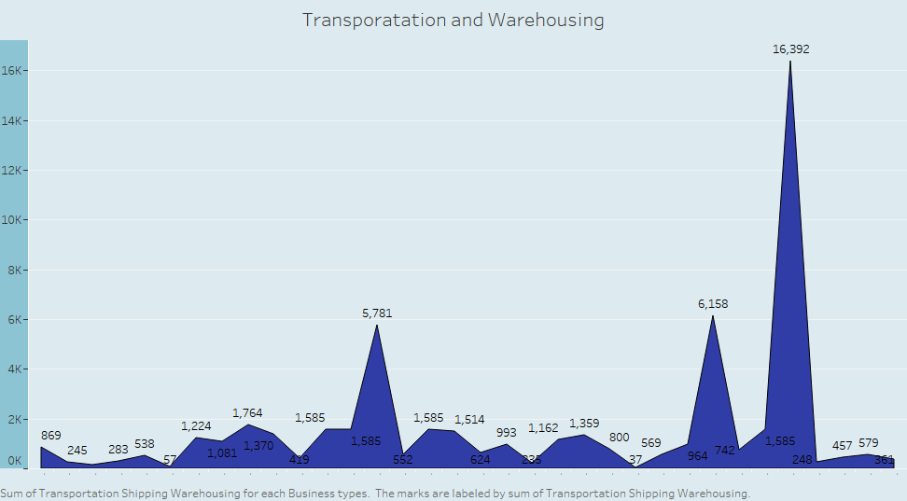

ANNUAL PAY ROLL
ADVERTISEIMENT COST
CONTRACT LABOUR VS EMPLOYEE
EMPLOYEE (INSURANCE VS PENSION)
EQUIPMENT COSTS
EXPENSES YOY
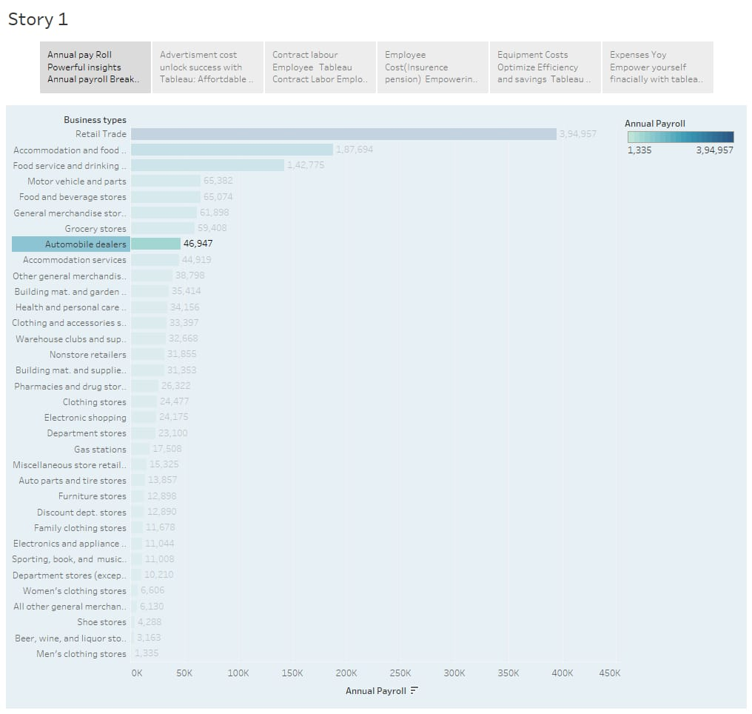

FUEL
MAINTENANCE OF BULDINGS
POWER EXPENDITURE
RENTAL PAYMENT MACHINERY
TAXES & LICENSES
TRANSPOTATION AND WAREHOUSING
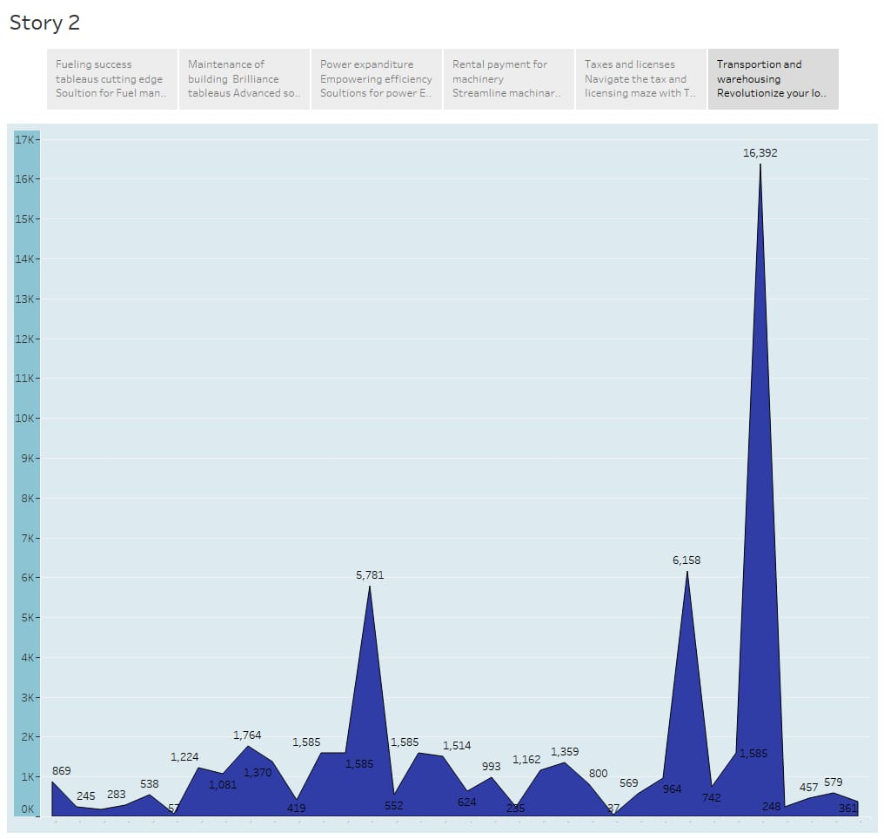

4. ADVANTAGES AND DISADVANTAGE :
ADVANTAGES:
» Estimating expenses helps you plan and budget for your business
ensure that you enough funds to cover costs.
» It aid's in making inform decision such as setting revenue goals, and
assessing profitability.
» Helps identify potential financial risks and prepare consistency plan.

DISADVANTAGE:
» Business expenses can change due to market fluctuations,
unexpected events, or growth, making it challenging predict accurately.
» Creating detailed expense estimate can be time-consuming and
required ongoing updates.
» Recycling sorely on estimates can load to complacency and neglect of
cost - cutting opportunities.

5. APPLICATION:
» Allow user to create account in their expenses.
» Categories expenses for better organization.
» Provide a farm user to input their expenses including amount and date
category.
» Allow user to set budget for different expenses and categories and
track their spending against their budget.

6. CONCLUSION:
» Begin to identifying expenses categories and gathering relevant data,
such as historical data and industrial benchmarks.
» Differentiating between fixed and variable expenses to better resource
and respond to changing circumstances.
» Proper estimation of expenses contribute to the overall financial health
of business and help you to manage cash flow effectively.

7. FUTURE SCOPE:
» Business will increasingly use advance data analytics and machine
learning algorithm to refine expenses estimation.
» Automatic tools will play a significant role in expense estimation.
» As environmental concerns grow business will need to estimate and
budget for sustainability and related expenses, such as co- friendly
package or renewable energy sources.

